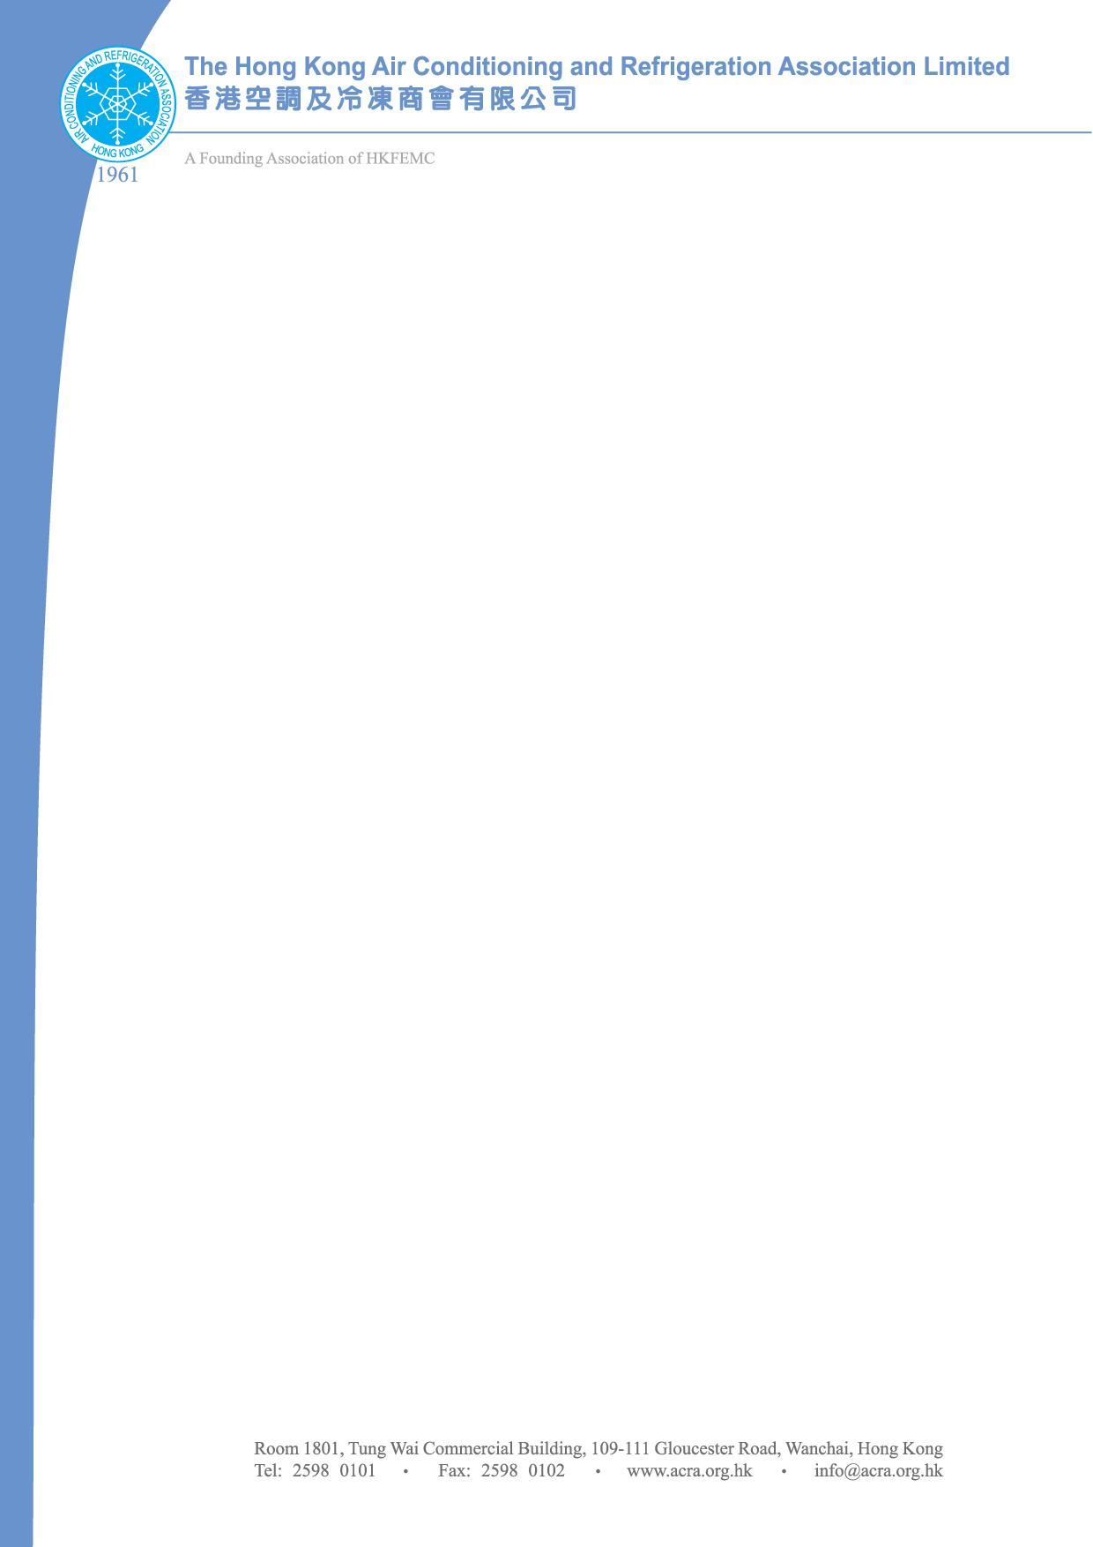
30 December 2010
To: ALL ACRA MEMBERS

ACRA Web Site Advertisement Renewal

ACRA web site advertisement has been launched for a year and most of our members find it good and useful. While we have our web site revamped, we would like to give you a new look with your company logos on it. In addition we add a page to promote our members’ products. We shall inform you immediately once registration starts.

The annual charge for this advertisement is HK$500. A detailed application form is attached for your information. Interested members please apply on or before 17 January 2011 and return e-mail to pollymui@acra.org.hk.

Cheque shall be made payable to “The Hong Kong Air Conditioning & Refrigeration Association Ltd.”and send to: Room 1801 Tung Wai Commercial Building, 109-111 Gloucester Road, Wanchai, Hong Kong
Attn: Ms.Polly Mui
-----------------------------------------------------------------------------------------------------------------------
REPLY SLUIP

Company Name | :
Contact Person | :
Web Site Address | :
Contact Telephone | :
□ I would like to enroll our company in this web site advertisement. A cheque for HK$500 will be sent to ACRA once our application is accepted.

Signature: ____________________________ Date : ___________________________

Note:
A rolling bar is set in our web site home page. Each company will include a company logo, company name, web site address, contact details & type of services or products under this web advertisement. Max. of 50 words are allowed (Chinese or English both are the same).

